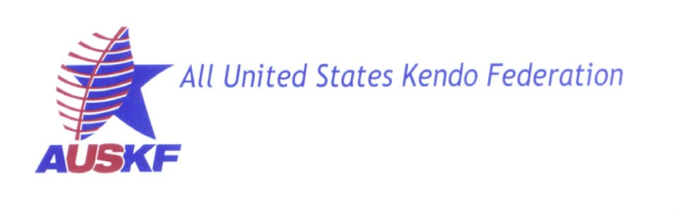
Request for Kendo/Iaido Examination by an Affiliate
Organization of the AUSKF

Kendo / Iaido / Jodo
(circle one item above)
Please fill out one form per shinsa.

Requesting Rank: Exam Date: ____/____/_______ (MM / DD/ YYYY)
(Kyu / Dan)

AUSKF ID No or FIK ID No:

FIK or AUSKF Member Federation:

Name of the affiliate that will conduct the test: _All United States Kendo Federation__

Name: ______________________/_____________________/_____________________
(Last) (First) (Middle)

Address
(Street)

/ /
(City) (State) (Zip)

Phone: __________________ E-Mail: ___________

Date of Birth: _____/_____/_________ (MM / DD/ YYYY) Age: __________________

Present Rank: Date Received:

List any handicaps, injuries, etc.:

☐ I certify that the member listed above is an active member of our federation.*
*(AUSKF members must have an active 2019 membership)

(Signature of FIK/AUSKF Member Federation President) (Date)

* To avoid mistakes and delays, please print clearly.

* Please attach this to your 2019 AUSKF Iaido Summer Camp and Jodo Seminar online registration from or send to monica.iwakabe@auskf.org by June 9, 2019.

